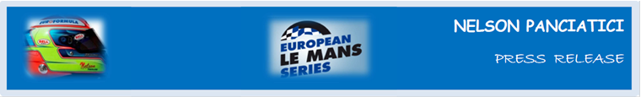

**EUROPEAN LE MANS SERIES 2013 – ROUND 2:**

**3 HOURS OF IMOLA (May 17 & 18)**

**ALPINE AND NELSON PANCIATICI ON A FORWARD MOMENTUM!**

The competitors of the European Le Mans Series will race in the second challenge of the season in Italy, on the Autodromo Enzo & Dino Ferrari in Imola, where the Alpine A450 is among the favourites. With a best time in the official ELMS tests on the Castellet circuit, the Alpine A450 finished just short of a podium in the first race at Silverstone because dramatic weather forced the stewards to stop the race before the end for safety reasons. Nelson Panciatici and the entire Signatech-Alpine team, managed by Philippe Sinault, want to continue this forward momentum and, this weekend in Imola, create the performance to match their potential.

Nelson Panciatici, who will discover the very technical track that is Imola, has trained assiduously on the Ellip6 simulator which reproduces the same sensations as those in the race car. He and his engineer have reviewed the tuning of various controls in order to have an efficient car from the first run. As this circuit is known to be physically demanding, Nelson has also followed a specific fitness regime.

Even though the competition looks tough, Nelson feels confident:

*“Since the start of the season we have shown our level of performance, be it in a lap or a relay. We now want to consolidate that with a good result and, even though I don’t know the circuit, I feel ready. On the Ellip6 simulator the track looks very technical with quite complex corners and chicanes but with my co-driver, Pierre Ragues, we make a balanced and fast team, which should allow us to reach lead positions and aim for at least one podium. Our engineer, Olivier, has managed to adapt our Alpine A450 well with the Michelin tyres and we have improved still more in their management. The work plan for Le Mans is already well under way and that will help this weekend. We took a few points at Silverstone which could turn out to be important by the end of the year, for now we must get back into the pack lead by being in front, I can’t wait to get to Imola!”*

Alpine is back in Endurance after 35 years absence with the aim to play lead roles, and to represent this mythical marque gives the whole team the strongest motivation to reach their objectives. Nelson Panciatici will want, no doubt, to add his contribution to the sporting rebirth of Alpine!

For more information on Nelson PANCIATICI, please visit[**www.nelsonpancia.fr**](http://www.nelsonpancia.fr)

[**facebook Join Nelson's Fan Club on Facebook!**](http://www.facebook.com/pages/Nelson-Panciatici/90065452450)