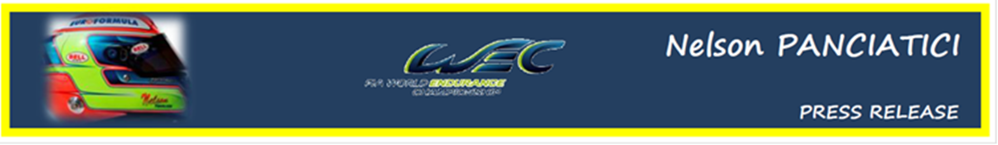
FIA WORLD ENDURANCE CHAMPIONSHIP – ROUND 4: 6 HOURS OF SILVERSTONE (25 & 26 August 2012)
NELSON PANCIATICI IS READY TO FACE THE COMPETITION

The end of the Le Mans 24 Hours, in which Nelson Panciatici came really close to stepping up on his first podium of the season, marked the beginning of a long summer break which could not end soon enough for the G DRIVE BY SIGNATECH NISSAN
The 6 Hours of Silverstone are the starting gun for a series of five races on three continents in two months. Needless to say, the drivers will have to stay sharp in the face of some very stiff competition in the LMP2 category.
Nelson Panciatici continues his apprenticeship at Silverstone, in a discipline he discovered for the first time at Spa Francorchamp at the start of the year and whose characteristics, notably of traffic management, take some time to adapt to. On the other hand, looking back over his first two races, we can say that he's fast learner!
The ORECA 03 NISSAN #26, which benefits from all the attention of the team dear to Philippe Sinault, is among the favourites in the LMP2 category and Nelson Panciatici is ready to take on the competition:
"I feel fully confident as we go into this second part of the season," says Nelson. " We showed them in Le Mans 24 Hours that we were in the competition. My co-drivers, Pierre and Roman, and I form a balanced team and we're fast with nothing to envy the other favourites. Our Oreca 03 Nissan is very competitive and easy to drive, which is an advantage in the endurance races. Well supported by the full G-Drive Racing by Signatech Nissan team, we're capable of victory, or at the very least a podium. I know that the competition will be tough but we've prepared ourselves well. Also, I know Silverstone well for having raced there in single-seaters and I like this circuit a lot, especially the rapid sequence in the Becketts. We're not yet half way through the championship, we have five races left to make our mark and we all want to get there as quickly as we can!"
The race will certainly be very lively, especially in the LMP2 category, and the whole G DRIVE RACING BY SIGNATECH NISSAN can count on their drivers to battle into the lead!
For more information on Nelson PANCIATICI, please visit www.nelsonpancia.fr
Join Nelson's Fan Club on Facebook!

